Project Design Phase-II Technology Stack (Architecture & Stack)

|  |  |
| --- | --- |
| Date | 29 October 2023 |
| Team ID | Team-592600 |
| Project Name | Alzheimer disease prediction |
| Maximum Marks | 4 Marks |

Technical Architecture:

The Deliverable shall include the architectural diagram as below and the information as per the table1 & table 2

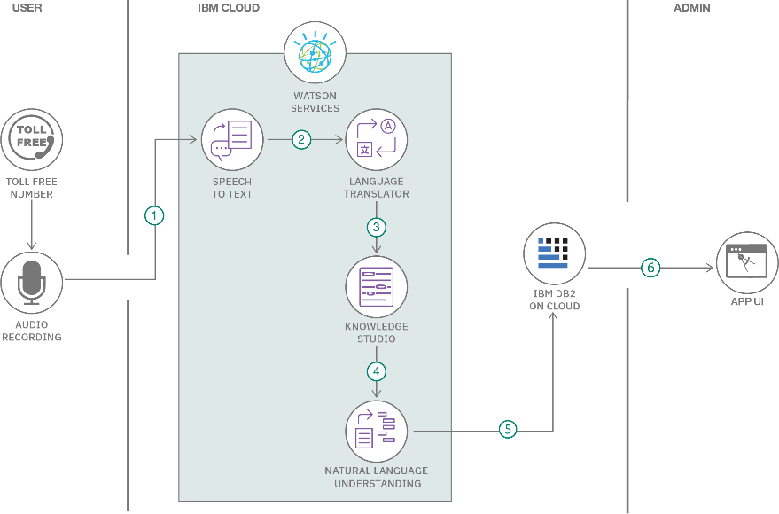

Table-1 : Components & Technologies:

|  |  |  |  |
| --- | --- | --- | --- |
| **S.No** | **Component** | **Description** | **Technology** |
| 1. | User Interface | Website | HTML, CSS |
| 2. | Application Logic-1 | Logic applied in application | Python |
| 3. | File Storage | File storage requirements | Local Filesystem |
| 4. | Machine Learning Model | Image Classification | CNN, Xception |
| 5. | Infrastructure (Server / Cloud) | Application Deployment on Local System Local Server Configuration. | Local System. |

Table-2: Application Characteristics:

|  |  |  |  |
| --- | --- | --- | --- |
| **S.No** | **Characteristics** | **Description** | **Technology** |
| 1. | Open-Source Frameworks | List the open-source frameworks used | Flask, Tensor FLow |
| 2. | Security Implementations | List all the security / access controls implemented, use of firewalls etc. | NA |
| 3. | Scalable Architecture | Justify the scalability of architecture (3 – tier, Micro-services) | NA |

|  |  |  |  |
| --- | --- | --- | --- |
| **S.No** | **Characteristics** | **Description** | **Technology** |
| 4. | Availability | Justify the availability of application (e.g. use of load balancers, distributed servers etc.) | NA |
| 5. | Performance | Design consideration for the performance of the application (number of requests per sec, use of  Cache, use of CDN’s) etc. | - |